|  |  |  |  |  |  |  |
| --- | --- | --- | --- | --- | --- | --- |
| PET ID | PET NAME | PET TYPE | PET AGE | OWNER | VISIT DATE | PROCEDURE |
| 246 | ROVER | DOG | 12 | SAM COOK | JAN 13/2002 | 01 - RABIES VACCINATION |
|  |  |  |  |  | MAR 27/2002 | 10 - EXAMINE and TREAT WOUND |
|  |  |  |  |  | APR 02/2002 | 05 - HEART WORM TEST |
| 298 | SPOT | DOG | 2 | TERRY KIM | JAN 21/2002 | 08 - TETANUS VACCINATION |
|  |  |  |  |  | MAR 10/2002 | 05 - HEART WORM TEST |
| 341 | MORRIS | CAT | 4 | SAM COOK | JAN 23/2001 | 01 - RABIES VACCINATION |
|  |  |  |  |  | JAN 13/2002 | 01 - RABIES VACCINATION |
| 519 | TWEEDY | BIRD | 2 | TERRY KIM | APR 30/2002 | 20 - ANNUAL CHECK UP |
|  |  |  |  |  | APR 30/2002 | 12 - EYE WASH |

1NF

|  |  |  |  |  |  |  |  |
| --- | --- | --- | --- | --- | --- | --- | --- |
| PET ID | PET NAME | PET TYPE | PET AGE | OWNER | VISIT DATE | PROCEDURE_ID | PROCEDURE Description |
| 246 | ROVER | DOG | 12 | SAM COOK | JAN 13/2002 | 01 | RABIES VACCINATION |
| 246 | ROVER | DOG | 12 | SAM COOK | MAR 27/2002 | 10 | EXAMINE and TREAT WOUND |
| 246 | ROVER | DOG | 12 | SAM COOK | APR 02/2002 | 05 | HEART WORM TEST |
| 298 | SPOT | DOG | 2 | TERRY KIM | JAN 21/2002 | 08 | TETANUS VACCINATION |
| 298 | SPOT | DOG | 2 | TERRY KIM | MAR 10/2002 | 05 | HEART WORM TEST |
| 341 | MORRIS | CAT | 4 | SAM COOK | JAN 23/2001 | 01 | RABIES VACCINATION |
| 341 | MORRIS | CAT | 4 | SAM COOK | JAN 13/2002 | 01 | RABIES VACCINATION |
| 519 | TWEEDY | BIRD | 2 | TERRY KIM | APR 30/2002 | 20 | ANNUAL CHECK UP |
| 519 | TWEEDY | BIRD | 2 | TERRY KIM | APR 30/2002 | 12 | EYE WASH |

2NF

PET (key = PET ID)

|  |  |  |  |  |
| --- | --- | --- | --- | --- |
| PET ID | PET NAME | PET TYPE | PET AGE | OWNER |
| 246 | ROVER | DOG | 12 | SAM COOK |
| 298 | SPOT | DOG | 2 | TERRY KIM |
| 341 | MORRIS | CAT | 4 | SAM COOK |
| 519 | TWEEDY | BIRD | 2 | TERRY KIM |

PROCEDURE ( key:PROCEDURE_ID)

|  |  |
| --- | --- |
| PROCEDURE_ID | PROCEDURE Description |
| 01 | RABIES VACCINATION |
| 10 | EXAMINE and TREAT WOUND |
| 05 | HEART WORM TEST |
| 08 | TETANUS VACCINATION |
| 20 | ANNUAL CHECK UP |
| 12 | EYE WASH |

Pet Visit (key: pet id+ visit date+ procedure ID)

|  |  |  |
| --- | --- | --- |
| PET ID | VISIT DATE | PROCEDURE_ID |
| 246 | JAN 13/2002 | 1 |
| 246 | MAR 27/2002 | 10 |
| 246 | APR 02/2002 | 5 |
| 298 | JAN 21/2002 | 8 |
| 298 | MAR 10/2002 | 5 |
| 341 | JAN 23/2001 | 1 |
| 341 | JAN 13/2002 | 1 |
| 519 | APR 30/2002 | 20 |
| 519 | APR 30/2002 | 12 |

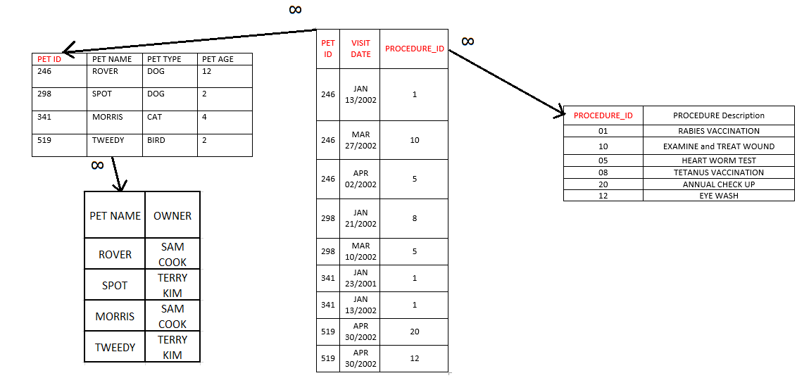3NF

2. Invoice

|  |  |  |  |
| --- | --- | --- | --- |
| PET ID | PET NAME | PROCEDURE | OWNER |
| 246 | ROVER | 01 – RABIES VACCINATION | SAM COOK |
| 341 | MORRIS | 01 – RABIES VACCINATION | SAM COOK |

|  |  |
| --- | --- |
| PET NAME | PROCEDURE |
| ROVER | 01 – RABIES VACCINATION |
| MORRIS | 01 – RABIES VACCINATION |

|  |  |  |
| --- | --- | --- |
| PROCEDURE | PET TYPE | AMOUNT |
| 01 – RABIES VACCINATION | DOG | 30.00 |
| 01 – RABIES VACCINATION | CAT | 24.00 |